A Brief Guide to the Neververse:

Table of Contents:

General Laws & Differences............................................................................................ Page 1

Locations & the World of Never...................................................................................... Page 2

Important Facts................................................................................................................ Page 6

General Laws & Differences:

While reading Never, one may notice some things don't quite line up with the iconic Pokémon games and their set of rules. This is not blatant disregard or sheer forgetfulness, rather, it's a few liberties taken to help the story flow better. The alterations are as follows:

1. Pokémon can learn more than four moves:

The famous four-move limit isn't a concern within the Neververse. Instead, pokémon contentiously learn new moves throughout their lives without having to forget previous ones. However, just like humans, moves they don't practice eventually become weaker, and are rendered useless or forgotten completely if they remain unused for years.

2. Maturity plays a part in evolution:

Although brute-strength and other conditions are still a factor in pokémon evolutions, another requirement is emotional maturity. Because of this, each pokémon in the Neververse evolves at a different age, even if they're of the same species and skill level. Once the process begins, it is impossible to stop or interrupt unless the pokémon is killed.

3. Pokémon don't have impunity:

Due to pokémon being considered at least semi-sentient around the world, several police forces have begun imprisoning or putting down pokémon for rape and murder (killing is lawful if the predator eats its prey). If a pokémon is a witness to murder or a victim of rape, they may report the crime to a translator (a pokémon who knows a human language). As this is a recent development in the police force, the process of verifying a victim's report is still sloppy, and most pokémon aren't aware of its existence.

Locations & the World of Never:

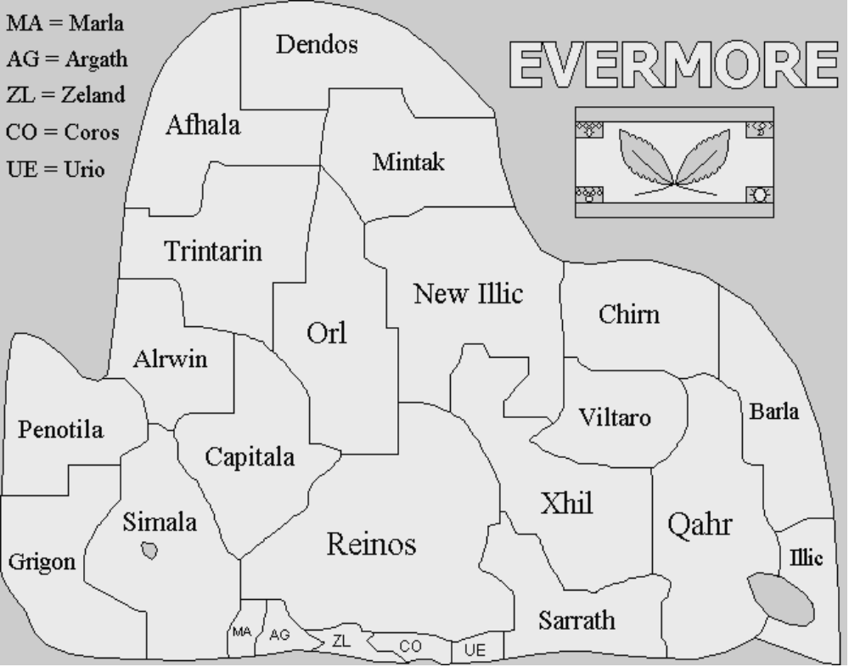

1. Evermore:

Evermore is warm, tropical continent located near the center of the vast Nocturne Ocean (one of the only two oceans in Never). A good portion of the story takes place in Grigon (bottom left), but its other states, and the other continents, are hardly left unexplored. Evermore is the 2nd smallest country, spanning 1,307 wide and 1,122 miles long.

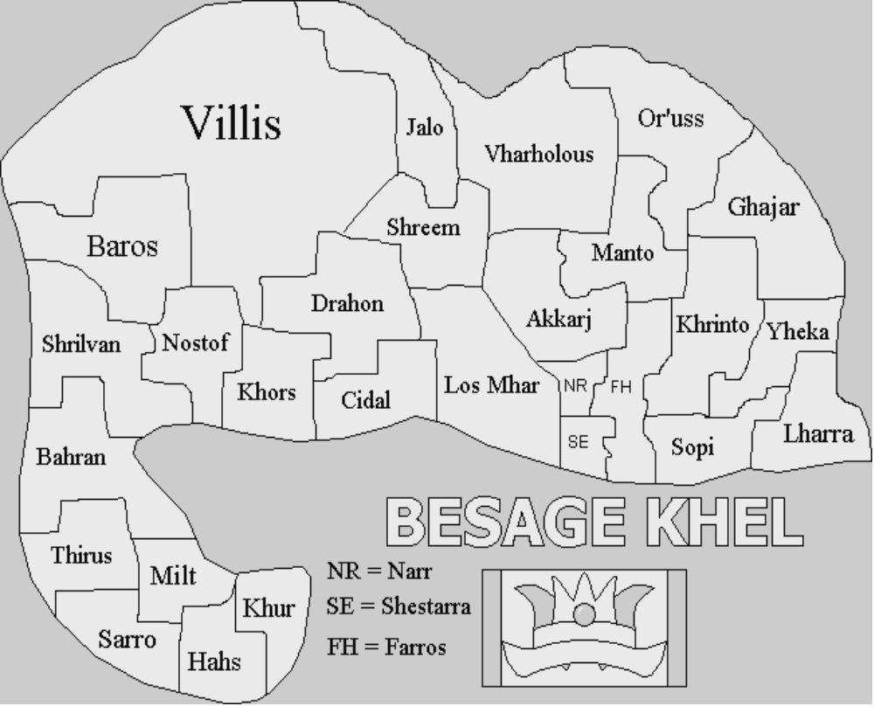

2. Besage Khel:

Besage Khel is the hottest continent on the planet, with most of its states averaging at a toasty 85° F and some even reaching beyond 100° F during the summer. The coldest state is Jalo, which drops to the 40s during winter. Slowkings played an important part in the country's founding, and are still greatly respected by some inhabitants. However, laws protecting slowkings from being killed for human consumption have recently been abolished. Besage Khel is the 3rd largest country, spanning 1,924 miles wide and 1,759 miles long.

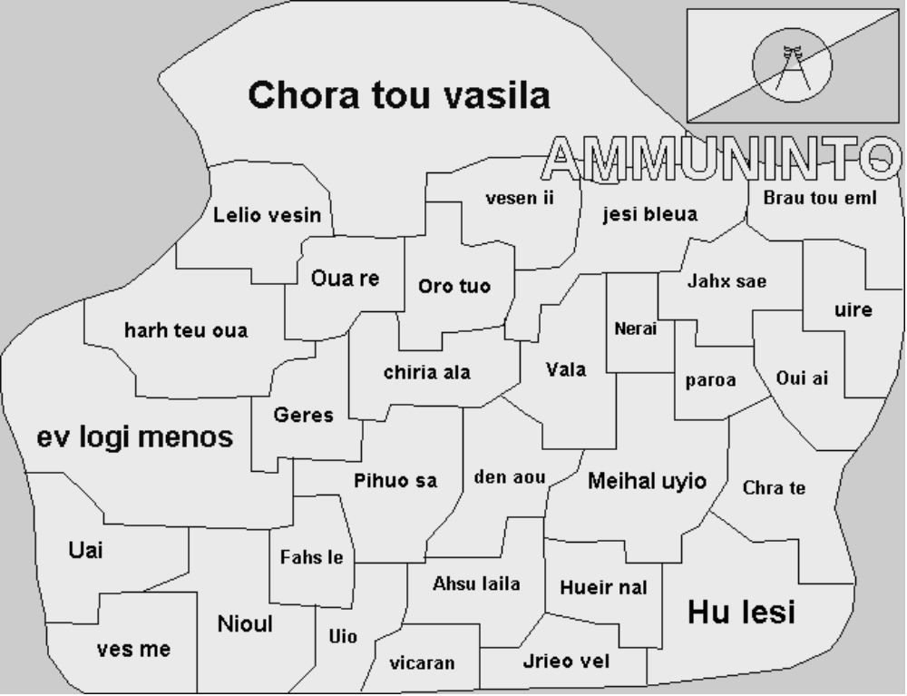

3. Ammuninto:

Ammuninto is the most densely populated country in the world, playing host to roughly 3,500,000,000 humans and several million pokémon. Because of its many ancient structures and works of art, Ammuninto brings in countless tourists each year. The native language here is Greek. Ammuninto is the 2nd largest country, spanning 2,472 miles wide and 2,111 miles long.
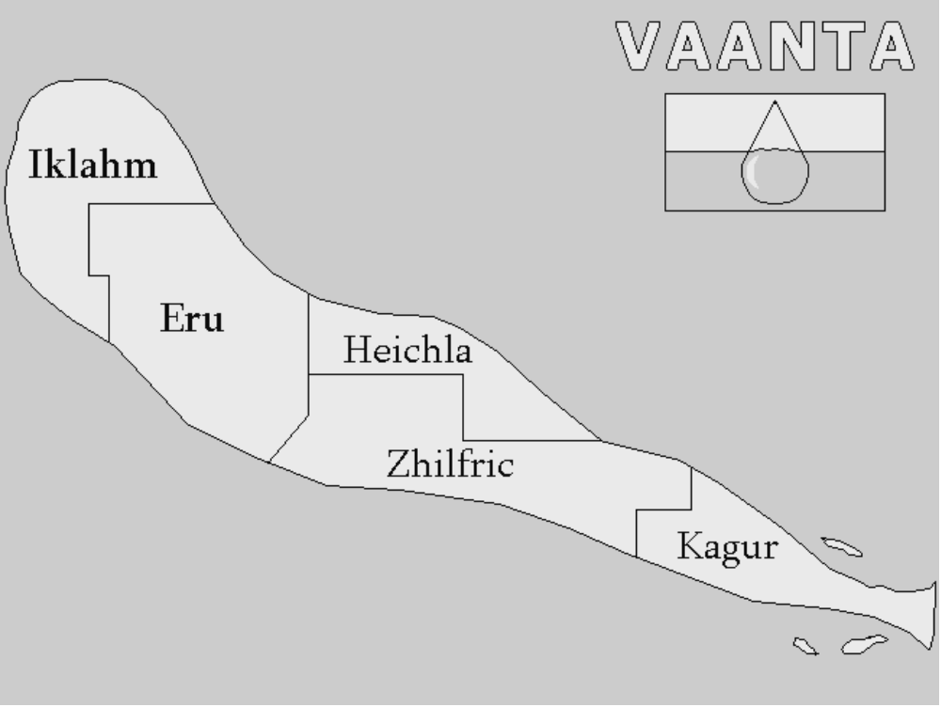
4. Vaanta:

Located to the northeast, Vaanta is remarkable for few things other than its cold weather and small size. While its snowy forests and terrain are often beautiful, most people prefer Evermore and Ammuninto for sightseeing purposes. However, Vaanta is known for its crystal-clean waters. It is believed humans and pokémon who live here live longer, due to the pure and unpolluted environment. Vaanta is the smallest country, spanning 536 miles wide and 409 miles long.


5. Crescenten:

Crescenten is a frozen, mostly barren land that is too cold for many to survive. While the bottom tip is capable of reaching relatively warm temperatures, anything past that point averages around -50° F. There is a perfectly ovular, giant frozen lake near the center of Crescenten that seems to repel any and all snow about to fall on it. Researching are still struggling to understand what force is pushing the snow away. Crescenten is the largest country, spanning 5,799 miles wide and 4,620 miles long.

Important Facts:

Before you stop reading this guide, there are a few more things you need to know about the Neververse.

1. Human population is decreasing:

There has been a recent pandemic sweeping the world, and the blame has been put on pokémon. Experts believe pokémon are spreading an airborne disease that, while harmless or even unnoticeable to pokémon themselves, is lethal to humans. Because pokémon and humans live so closely together, the disease has been spread rapidly from country to country. Some governments have legalized hunting pokémon, while others have trainers and breeders confine them to isolation. Although the outbreak began only a few years ago, the disease is estimated to have killed around 20,000,000 people.

2. Mating habits aren't dependent on species:

Unlike reality, mating for life and other various mating habits aren't restricted to certain species. Rather, it depends solely on the personality of the pokémon and their long-term interests. Like humans, they may have many casual relations, become mated either short-term or long-term, or even have multiple mates.

3. Species aren't reliant on the mother:

In the Pokémon games, a baby's species is determined by what the mother is (example: a mother blastoise would always birth a baby squirtle). In the Neververse, however, the range expands to include both the mother and the father (the mother blastoise might birth a baby charmander, if impregnated by a charizard).

4. Never doesn't take place in present-day:

This isn't terribly important to note, as Never focuses much more on pokémon rather than humans, but it might explain any slight technological advances one may notice. The prologue takes place during November 18th, 2034. No groundbreaking achievements have been made technology or medical-wise.

